**Question1.**

**(a)**

I am using Microsoft Word as a word processor. I’m using Zotero as a reference manager.

**(b)**

Yes I will use the cite-as-you-write approach because this approach ensures citation accuracy and reduces the workload and error risk associated with manual formatting later on.  
  
  
  
  
**Question2**

**(a)**

arXiv.org significantly contributes to scholarly research dissemination by allowing researchers to swiftly publish and openly share their academic work. It provides convenient services, including easy web-based access for readers and data retrieval via APIs, and emphasizes collaborative, open research practices. Major disciplines covered by arXiv include physics, mathematics, computer science, quantitative biology and finance, statistics, electrical engineering, systems science, and economics . [1]

**(b)**

Papers in e-print archives like arXiv and online conference repositories like AAAI Proceedings differ mainly in peer review, publication status, accessibility, and content versioning. arXiv hosts non-peer-reviewed preprints allowing rapid dissemination, with authors able to continuously update versions. Thus, arXiv publications are informal and preliminary [1]. Conversely, AAAI Proceedings include peer-reviewed, formally accepted research papers. These papers undergo rigorous review processes, ensuring higher credibility and recognition as formal publications within academic communities [2]. Furthermore, AAAI Proceedings typically represent final research versions and hold significant value in citation and academic evaluation, while arXiv papers are preliminary and require subsequent formal publication for official scholarly recognition [1], [2].

**(c)**

Google Scholar and Web of Science differ significantly in their selection of indexed publications. Google Scholar broadly indexes various academic materials, including journal articles, conference papers, book chapters, theses, technical reports, and preprints (e.g., from arXiv), demonstrating wider inclusivity and coverage [3]. Conversely, Web of Science primarily indexes peer-reviewed journal articles and conference proceedings, typically excluding informal content such as preprints, technical reports, or theses, thus prioritizing rigorous peer-review standards, academic quality, and research impact [4].

**(d)**

The arXiv identifier (e.g., 2006.10204) typically consists of the year and month of submission ("2006" indicates it was uploaded in June 2020) followed by a unique number ("10204"). Each time the author updates the paper, the URL will include an additional version tag such as v2, v3, and so on.[5]

**(e)**

“We present an approach to efficiently detect the 2D pose of multiple people in an image.”[6]

“Realtime multi-person 2D pose estimation is a key component in enabling machines to have an understanding of people in images and videos.”[7]

**(f)**

The paper introduces OpenPose, a real-time method for detecting 2D poses of multiple people simultaneously by utilizing Part Affinity Fields It efficiently identifies keypoints and establishes connections between them, enabling accurate pose estimation even with overlapping individuals in complex scenes.

Paraphrasing methods used: synonyms, changing voice and changing word order.

**(g)**

|  |  |  |  |
| --- | --- | --- | --- |
| Article version | Number of Google  Scholar citations | Number of Web of  Science citations | Date(s) of access |
| Peer-reviewed | 6961 | 2834 | 7/4/2025 |

**(h)**

|  |  |  |  |  |
| --- | --- | --- | --- | --- |
|  | Journals | Refereed Conferences | Preprints and unrefereed conferences | Date of access |
| Title of publication of citing articles | Nature Methods  Computer Vision and Image  Understanding | IEEE/CVF Conference on Computer Vision and Pattern Recognition (CVPR)  AAAI Conference on Artificial Intelligence (AAAI)  ACM SIGKDD Conference | arXiv | 7/4 2025 |
| Total Count | 2 | 3 |  |  |

The ten most relevant papers citing Cao et al. predominantly appear in peer-reviewed conferences, partially supporting the previous answer in 2(c).

**Question3**

**(a)**  
The following issues are present:

1. Insufficient citation details: The student only cited “(Domingos et al., 2012)” in APA style, without using the required IEEE format. Moreover, no specific page numbers were provided, nor was the referenced work by Vapnik [23] mentioned.
2. Potential plagiarism or inadequate paraphrasing: The quoted text is very similar to the original, especially in phrases such as “support vector machines can effectively have an infinite number of parameters without overfitting” and “sign(sin(ax)).” Although the author was cited, the wording is almost identical to the source.
3. Omission of secondary citation: In the original text, the function example was backed by a reference to Vapnik (1995) [23], but the student failed to indicate this secondary source.
4. Inconsistent citation styles: The student used APA style in the answer, while the original example followed ACM style, and the assignment requires IEEE style.

**(b)**  
The student should:

1. Use the correct IEEE citation format, for example: “[1] P. Domingos, ‘A few useful things…’”.
2. Indicate the specific source and page number for any quotes or paraphrases, using citation numbers and providing complete information in the reference list. If the original text includes a secondary citation, this should also be clearly noted.
3. Appropriately paraphrase: If using sentences that are identical or very similar to the original, quotation marks should be used, or the sentence should be thoroughly rephrased and properly cited.
4. Preserve the author's comparisons or examples: The argument involving the function sign(sin(ax)) originates from another source and should be accompanied by a secondary citation or by including Vapnik (1995) [23] in the reference list, along with an explanation of how the source was cited.

**Question 4  
  
(a)**Differences: IEEE typically uses a numbered citation format like “[x]” and lists references in numerical order at the end of the document.

APA typically uses an in-text format like “(Author, Year)” and arranges references alphabetically by the first letter of the author's last name at the end of the document.

Examples Show in :  
“Deep learning allows computational models that are composed of multiple processing layers to learn representations of data with multiple levels of abstraction.”[1] （LeCun et al., 2015）  
IEEE:

[1] Y. LeCun, Y. Bengio, and G. Hinton, “Deep learning,” Nature, vol. 521, no. 7553, pp. 436–444, May 2015, doi: 10.1038/nature14539.

APA:  
(LeCun et al., 2015)LeCun, Y., Bengio, Y., & Hinton, G. (2015). Deep learning. Nature, 521(7553), 436–444. https://doi.org/10.1038/nature14539

**(b)**

Google scholar h5 index: 85

Web of science : 14

Scope: 26

The differences in h-index values across Google Scholar (**85**), Web of Science (**14**), and Scopus (**26**) reflect distinct indexing criteria and coverage scope of these databases. Google Scholar indexes a wide range of academic sources, including preprints and informal publications, thus typically presenting a higher h5-index. Web of Science, with stricter indexing standards limited primarily to peer-reviewed journal articles and certain conference papers, yields a significantly lower h-index. Scopus, with intermediate coverage, indexes a broader selection than Web of Science but is still more selective than Google Scholar, resulting in an h-index between the two.

**(c)**

The **Journal Impact Factor (JIF)** can be used as a metric to evaluate the impact of **Article 2**. This indicator is chosen because the impact factor of a journal reflects the average number of citations received by articles published in that journal, providing an intuitive measure of its academic influence.

**Question 5:**

**(a)**

Dhruv Batra

**(b)**

|  |  |  |  |  |
| --- | --- | --- | --- | --- |
| Author order | Name | Affiliation | Academic or professional position | Corresponding author? |
| Author #1 | Ramprasaath R. Selvaraju | Georgia Institute of Technology | Ph.D. Student | No |
| Author #2 | Michael Cogswell | Georgia Institute of Technology | Ph.D. Student Research Scientist | No |
| Author #3 | Abhishek Das | Georgia Institute of Technology | Ph.D. Student | No |
| Author #4 | Ramakrishna Vedantam | Georgia Institute of Technology | Ph.D. Student | No |
| Author #5 | Devi Parikh | Georgia Institute of Technology | Associate Professor | No |
| Author #6 | Dhruv Batra | Georgia Institute of Technology | Associate Professor | Yes |

**Question 6:**

**(a)**I have chosen acceptance rate and the h5 index as my two conference-level metrics.   
The combination of these two measures offers both a view of how selective a conference is (acceptance rate) and how well-cited its published papers become (h5 index). In practice, no single metric is perfect for all situations, so it is safer to consider multiple indicators. Comparing acceptance rate with CORE ranking can further clarify a conference’s reputation. While CORE ranking provides a broad classification (A*, A, B, or C) based on factors like historical prestige, the acceptance rate offers a more immediate and annually updated view of how competitive the conference is.

Acceptance rate:  
For IJCNN, there is no acceptance rate data available for 2024, but the organizers have stated a target acceptance rate of 40% for 2025.

In contrast, CVPR has a reported acceptance rate of 23.6 %for 2024.

Their h5 indexes also differ significantly:

IJCNN’s h5 index is 64,

CVPR’s is 440.

Conclusion:  
I note that IJCNN’s missing data for 2024 makes it harder to compare its current selectivity with CVPR. We only have the 2025 target acceptance rate and the h5 index to estimate IJCNN’s quality. This gap suggests that while IJCNN may well be competitive, its actual acceptance data for 2024 remains unknown. Without confirmed figures, we must rely on the conference’s h5 index and forthcoming acceptance stats to assess its standing.

**(b)**

|  |  |  |  |
| --- | --- | --- | --- |
| Conference | Acceptance rate | H5-index | ANZSRC FoR codes |
| International Joint Conference on Neural Networks | None for 2024 Aim acceptance rate in 2025:40%[8] | 64[10] | 4611[12] |
| IEEE Conference on Computer Vision and Pattern | 23.6%[9] | 440[11] | 4603[13] |

**EDIT REFERENCE**: I manually edited the citations for the IJCNN CORE 2023 entry[12], and CVPR CORE 2023 entry[13] to include the conference name (“IEEE International Joint Conference on Neural Networks (IJCNN)”) and the name title of CVPR, the reference to CORE 2023 rankings, and the access date. Zotero’s default output had only the URL and the access date, so I added extra details to clarify which conference was referenced and to align with IEEE requirements for a descriptive title.

**Question7  
(a)**

Data Collection and Ownership: Verify proper authority to collect patient data, ensuring compliance with relevant legislation. Ownership typically resides with the healthcare institution or governing body granting data access.

Confidentiality and Privacy: Use methods such as anonymization or de-identification to protect patient identity. Limit access strictly to authorized personnel and systems.

Data Sharing: Any sharing of medical data must adhere to institutional and legal guidelines, ensuring minimal risk of re-identification.

Informed Consent: If applicable, patients should consent to how their data will be used, stored, and potentially shared or published. Researchers must communicate any risks, benefits, and scope of the study.

**(b)**  
Researchers should not simply remove outlier data points to improve performance. Doing so could be considered data manipulation and may undermine scientific integrity. Instead, they should:

1. Investigate Outliers: Determine whether these data points are genuine observations or due to errors in data collection.
2. Document Rationale: If outliers are excluded, thoroughly explain the reasons (for example clear measurement errors).
3. Maintain Transparency: Report analyses both with and without those data points and discuss the results.
4. Ethical Reporting: Ensure that the final publication reflects a fair account of the entire data set, preserving integrity and reproducibility.

**Question8  
(a)**  
Dr. Williams’ grant from a major oil company seeking to influence energy policy presents a perceived and potential conflict of interest. Their funding source might bias—or appear to bias—the research outcomes and interpretations, especially since the sponsoring company has a vested interest in shaping renewable energy discourse. This situation raises concerns about impartiality, transparency, and the credibility of the study’s conclusions.  
  
**(b)**  
To preserve research integrity, Dr. Williams should:

1. Disclose the funding source and any related interests fully and promptly in all publications and presentations.

2. Implement a conflict management plan, for instance by having independent reviewers examine the research methods and findings.

3.Maintain autonomy over data collection, analysis, and reporting, ensuring no undue influence by the sponsor on the study’s design or outcomes.

**Question9:**

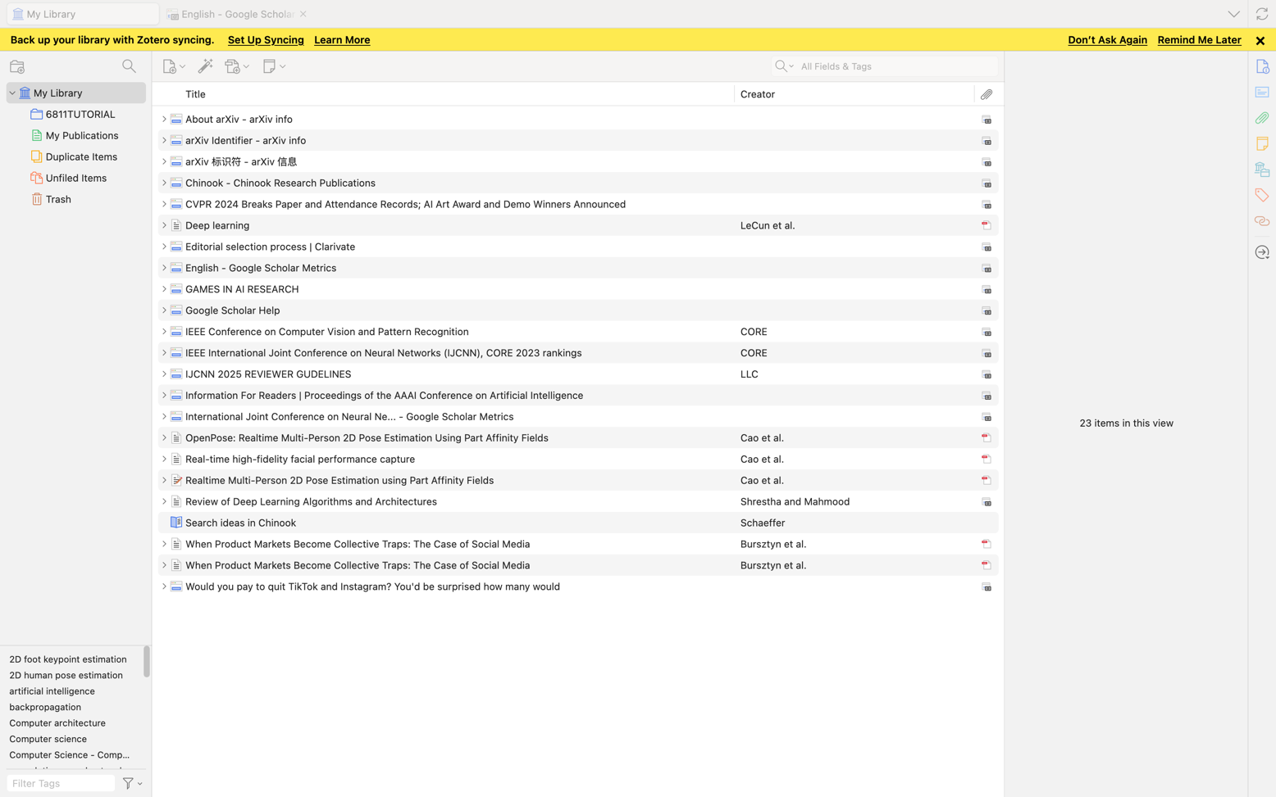

**NOTE: ALL CITATION USED IN THIS ASSIGNMENT ARE INCLUDED. BUT THERE ARE SOME CITATIONS USED IN THE TUTORIAL TOO.**

**Reference**

[1] “About arXiv - arXiv info.” Accessed: Apr. 07, 2025. [Online]. Available: https://info.arxiv.org/about/index.html

[2] “Information For Readers | Proceedings of the AAAI Conference on Artificial Intelligence.” Accessed: Apr. 07, 2025. [Online]. Available: https://ojs.aaai.org/index.php/AAAI/information/readers

[3] “Google Scholar Help.” Accessed: Apr. 07, 2025. [Online]. Available: https://scholar.google.com/intl/en/scholar/inclusion.html#content

[4] “Editorial selection process | Clarivate.” Accessed: Apr. 07, 2025. [Online]. Available: https://clarivate.com/academia-government/scientific-and-academic-research/research-discovery-and-referencing/web-of-science/web-of-science-core-collection/editorial-selection-process/

[5] “arXiv Identifier - arXiv info.” Accessed: Apr. 07, 2025. [Online]. Available: https://info.arxiv.org/help/arxiv_identifier.html

[6] Z. Cao, T. Simon, S.-E. Wei, and Y. Sheikh, “Realtime Multi-Person 2D Pose Estimation using Part Affinity Fields,” Apr. 14, 2017, arXiv: arXiv:1611.08050. doi: 10.48550/arXiv.1611.08050.

[7] Z. Cao, G. Hidalgo, T. Simon, S.-E. Wei, and Y. Sheikh, “OpenPose: Realtime Multi-Person 2D Pose Estimation Using Part Affinity Fields,” IEEE Trans. Pattern Anal. Mach. Intell., vol. 43, no. 1, pp. 172–186, Jan. 2021, doi: 10.1109/TPAMI.2019.2929257.

[8] C. C. LLC, “IJCNN 2025 REVIEWER GUDELINES,” IJCNN 2025. Accessed: Apr. 08, 2025. [Online]. Available: <https://2025.ijcnn.org/reviewers/ijcnn-2025-reviewer-gudelines>

[9] “CVPR 2024 Breaks Paper and Attendance Records; AI Art Award and Demo Winners Announced.” Accessed: Apr. 08, 2025. [Online]. Available: <https://cvpr.thecvf.com/Conferences/2024/News/Wrap_Release>

[10] “International Joint Conference on Neural Ne... - Google Scholar Metrics.” Accessed: Apr. 08, 2025. [Online]. Available: https://scholar.google.es/citations?hl=en&view_op=search_venues&vq=International+Joint+Conference+on+Neural+Networks&btnG=

[11] “English - Google Scholar Metrics.” Accessed: Apr. 08, 2025. [Online]. Available: https://scholar.google.com/citations?view_op=top_venues&hl=en&vq=en

[12] CORE, “IEEE International Joint Conference on Neural Networks (IJCNN), CORE 2023 rankings,” ICORE Conference Portal. Accessed: Apr. 08, 2025. [Online]. Available: https://portal.core.edu.au/conf-ranks/685/

[13] CORE, “IEEE Conference on Computer Vision and Pattern Recognition,” ICORE Conference Portal. Accessed: Apr. 08, 2025. [Online]. Available: https://portal.core.edu.au/conf-ranks/604/